AWS Message Synchronization Technical Design Document
Version: 1.0
Project: AWS Message Synchronization Framework
1. Introduction
Purpose
This document describes the technical design of the proposed AWS-based message synchronization framework. The solution is intended to capture changes occurring within the operational database, synchronize those changes with downstream systems, and maintain an Operational Data Store (ODS) for reporting purposes.
The architecture follows an event-driven design using managed AWS services to improve scalability, reliability, and maintainability while minimizing custom infrastructure management.
Business Objective
The current system requires multiple downstream applications to receive updates whenever business data changes.
Rather than integrating applications directly with one another, the proposed solution introduces a centralized event streaming platform that:
• Captures database changes in near real time
• Synchronizes data with an Operational Data Store
• Publishes notifications to downstream systems
• Decouples producers from consumers
• Enables future integrations with minimal architectural changes
2. High-Level Architecture
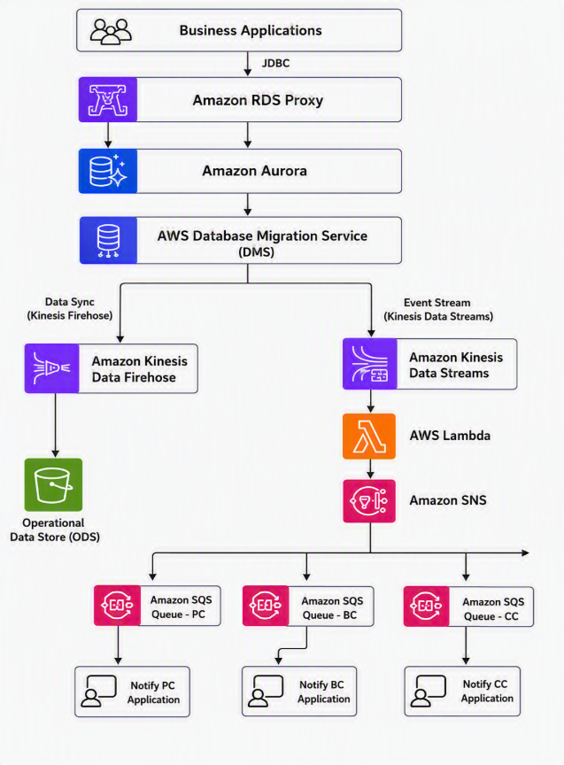

3. Architecture Overview
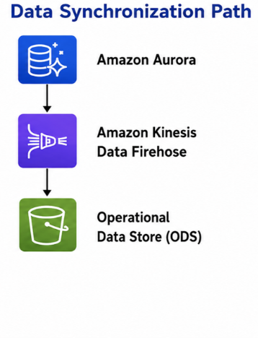
- Responsible for maintaining a synchronized Operational Data Store (ODS).
- Firehose continuously delivers database records into the ODS(MainFrame tables), allowing reporting workloads to execute independently of the production database.
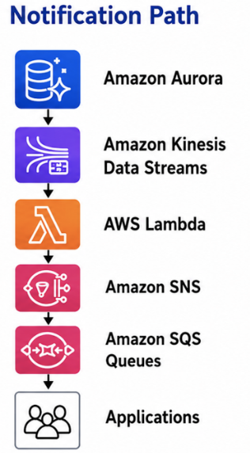
- Responsible for notifying downstream systems whenever business data changes.
- This path is optimized for low-latency event processing.
4. Amazon RDS Proxy
Purpose
Amazon RDS Proxy sits between the application and the Aurora database to efficiently manage database connections.
Why is it used?
Without a proxy, every application instance creates its own database connections. As traffic grows, Aurora may spend significant resources creating, maintaining, and closing connections.
RDS Proxy maintains a reusable connection pool, reducing connection overhead and improving scalability.
Benefits
• Connection pooling
• Improved database scalability
• Faster failover
• Reduced connection management overhead
• Supports secure authentication
5. Amazon Aurora

Purpose
Aurora serves as the primary transactional database for the system and acts as the authoritative source of business data.
Aurora is the primary transactional database that stores operational business data.
Every insert, update, or delete originates here before being propagated through the synchronization pipeline.
Aurora was selected because it provides high availability, automatic backups, managed failover, and strong performance while remaining compatible with standard relational databases.

Benefits
- High reliability and fault tolerance
- Reduced database administration effort
- Improved application availability
- Scalable performance for growing workloads
- Seamless integration with AWS ecosystem

6. Amazon Kinesis Data Streams
Purpose
Kinesis Data Streams captures change events in near real time.
Each database event becomes a stream record.
Unlike direct API communication, events remain available until consumers successfully process them.
Why not send directly to Lambda?
- Events are stored durably in the stream.
- Consumers can replay events if needed.
- Multiple consumers can read the same data independently.
- Processing can scale horizontally.
Why Kinesis?
Traditional architectures often require applications to invoke each downstream service directly.
This creates tight coupling.
Kinesis changes the architecture into an event stream.
New consumers simply subscribe to the stream.
Benefits
• Near real-time streaming
• Durable event storage
• Replay capability
• Ordered processing within shards
• Horizontal scalability

7. AWS Lambda
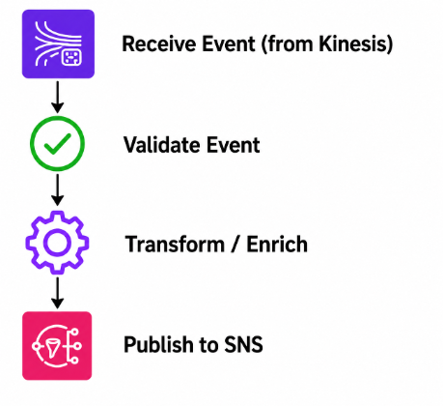

Lambda processes each event received from Kinesis.
Using Lambda eliminates the need to manage servers while providing automatic scaling based on incoming events.
8.Amazon SNS
SNS provides a publish-subscribe model.
Instead of Lambda sending notifications individually, Lambda publishes only once.
This significantly reduces application coupling.
Benefits
• One publisher
• Multiple subscribers
• Easy onboarding of new systems
• Highly scalable
9. Amazon SQS
Purpose
Amazon SQS provides reliable message queuing for downstream applications, ensuring messages are processed asynchronously and independently.
- Each downstream application owns a dedicated queue.
- Each consumer processes messages independently.
- If one consumer is unavailable, messages remain safely stored until processing resumes.

Benefits
• Reliable delivery
• Independent consumers
• Automatic retries
• Dead-letter queue support
• Fault isolation
10.Amazon Kinesis Data Firehose
Purpose
Amazon Kinesis Data Firehose provides a fully managed data delivery service that continuously transports operational data from the streaming platform to the Operational Data Store (ODS) for reporting and analytics.
Firehose continuously delivers operational data into the Operational Data Store.
Unlike Kinesis Data Streams, Firehose is optimized for managed data delivery rather than custom event processing.
It automatically handles buffering, batching, retries, and delivery, significantly reducing operational complexity and the need for custom data ingestion solutions.
Benefits
- Fully managed data delivery service
- Automatic buffering and batching
- Built-in retry and error-handling mechanisms
- Reduced operational overhead
- Reliable delivery to the ODS
- Scalable processing of large data volumes

Without ODS
Reports
↓
Aurora Database
Problems:
- Reports slow down production database.
- Business transactions and reporting compete for resources.
- Performance issues during peak hours.
Why ODS?
ODS = Operational Data Store
Think of it as a reporting copy of your production data.
Benefits:
- Production system remains fast
- Reporting does not impact transactions
- Historical and analytical queries run separately
- Better scalability
11. End-to-End Processing Flow
1. Business application updates Aurora.
2. Aurora generates a database change event.
3. Kinesis Data Streams receives the event.
4. Lambda processes the event.
5. Lambda publishes the processed message to SNS.
6. SNS distributes the message to all subscribed SQS queues.
7. Each downstream application independently consumes and processes its messages.
Simultaneously, Production reporting data remains synchronized.
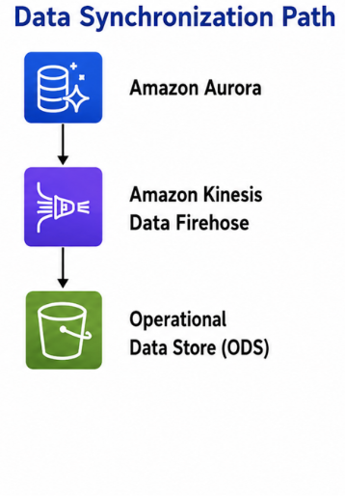
12.Future Extensibility
The architecture is designed to support future integrations with minimal changes. Additional consumers can subscribe to the SNS topic or process events from Kinesis without requiring modifications to the existing producer applications. This extensibility enables the platform to evolve as new business requirements emerge while preserving a loosely coupled, scalable architecture.
Q & A
How do you configure Kinesis Data Stream on AWS Aurora
Ans:
Aurora database changes are captured using AWS Database Migration Service CDC. AWS DMS reads committed insert, update, and delete operations from Aurora transaction logs and publishes them as JSON records into Amazon Kinesis Data Streams. Kinesis then acts as the real-time event stream that triggers Lambda-based processing and downstream notification through SNS and SQS.
Aurora Database
↓
AWS DMS CDC Task
↓
Kinesis Data Streams
↓
Lambda

Why use Kinesis? Why not send data using DMS with Lambda as DMS target?
Ans:
DMS cannot store information.
It can be used just to replicate or transfer data.
If we send messages from DMS to Lambda and for some reason Lambda fails to process it that message is gone.

Whereas Kinesis stream can store data for multiple consumers to process.

Kinesis handles spikes better
Imagine 50,000 records are updated in Aurora during a batch job.
DMS captures all changes.
If those changes hit Lambda directly, Lambda may get overwhelmed.
With Kinesis:
50,000 database changes
↓
Kinesis buffers records
↓
Lambda processes in batches

Example
Think of DMS as a person reading updates from a notebook.
Think of Lambda as a worker who performs actions.
Think of Kinesis as a message conveyor belt.
Person reads update → puts message on conveyor belt → worker picks it up
One-Line Summary
DMS captures the database changes, but Kinesis is used because Lambda needs a reliable stream to read from, with buffering, replay, scaling, and support for multiple consumers.

What kind of ODS are we planning to use? Like S3/DB?

Here the ODS is MainFrame Db2 tables.

